The Four Spiritual Laws

1. God loves you and created you to know Him personally.

(references contained on this Home Page are linked to the actual verses from the Bible, and should be read in context wherever possible.)
God's Love

"God so loved the world, that He gave His only begotten Son, that whoever believes in Him should not perish, but have eternal life" (John 3:16).

God's Plan

"Now this is eternal life: that they may know you, the only true God, and Jesus Christ, whom you have sent" (John 17:3, NIV). What prevents us from knowing God personally?

2. Man is sinful and separated from God, so we cannot know Him personally or experience His love.

Man is Sinful

"All have sinned and fall short of the glory of God" (Romans 3:23). Man was created to have fellowship with God; but, because of his own stubborn self-will, he chose to go his own independent way and fellowship with God was broken. This self-will, characterized by an attitude of active rebellion or passive indifference, is an evidence of what the Bible calls sin.

Man is Separated

"The wages of sin is death" [spiritual separation from God] (Romans 6:23). "...(Those) who do not know God and do not obey the gospel of our Lord Jesus...will be punished with everlasting destruction and shut out from the presence of the Lord..." (2 Thessalonians 1:8,9)

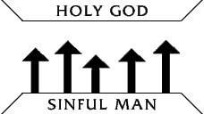

This diagram illustrates that God is holy and man is sinful. A great gulf separates the two. The arrows illustrate that man is continually trying to reach God and establish the personal relationship with Him through his own efforts, such as a good life, philosophy, or religion - but he inevitably fails. The third principle explains the only way to bridge this gulf..

3.Jesus Christ is God's only provision for man's sin. Through Him alone we can know God personally and experience God's love.

He Died in Our Place

"God demonstrates His own love toward us, in that while we were yet sinners, Christ died for us" (Romans 5:8).

He Rose From the Dead

"Christ died for our sins...He was buried...He was raised on the third day according to the Scriptures...He appeared to Peter, then to the twelve. After that He appeared to more than five hundred..." (1 Corinthians 15:3-6).

He is the Only Way to God

"Jesus said to him, 'I am the way, and the truth, and the life; no one comes to the Father, but through Me'" (John 14:6).

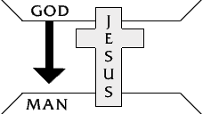

This diagram illustrates that God has bridged the gulf that separates us from Him by sending His Son, Jesus Christ, to die on the cross in our place to pay the penalty for our sins.

It is not enough just to know these truths...

4. We must individually receive Jesus Christ as Savior and Lord; then we can know God personally and experience His love.

We Must Receive Christ

"As many as received Him, to them He gave the right to become children of God, even to those who believe in His name" (John 1:12)

We Receive Christ Through Faith

"By grace you have been saved through faith; and that not of yourselves, it is the gift of God; not as a result of works that no one should boast" (Ephesians 2:8,9). When We Receive Christ, We Experience a New Birth (Read John 3:1-8.)

We Receive Christ by Personal Invitation

[Christ speaking] "Behold, I stand at the door and knock; if any one hears My voice and opens the door, I will come in to him" (Revelation 3:20).

Receiving Christ involves turning to God from self (repentance) and trusting Christ to come into our lives to forgive us of our sins and to make us what He wants us to be. Just to agree intellectually that Jesus Christ is the Son of God and that He died on the cross for our sins is not enough. Nor is it enough to have an emotional experience. We receive Jesus Christ by faith, as an act of our will.

These two circles represent two kinds of lives:

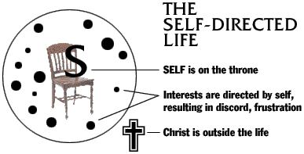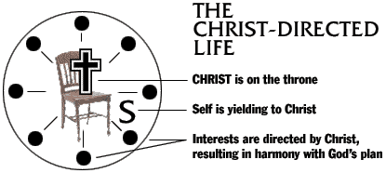

self-directed life Christ directed life

Which circle best represents your life?

Which circle would you like to have represent your life?

The following explains how you can receive Christ:

You Can Receive Christ Right Now by Faith Through Prayer

(Prayer is talking with God)

God knows your heart and is not so concerned with your words as He is with the attitude of your heart.

How to Know That Christ Is in Your Life

Did you receive Christ into your life? According to His promise in Revelation 3:20, where is Christ right now in relation to you? Christ said that He would come into your life and be your friend so you can know Him personally. Would He mislead you? On what authority do you know that God has answered your prayer? (The trustworthiness of God Himself and His Word.)

The Bible Promises Eternal Life to All Who Receive Christ

"The witness is this, that God has given us eternal life, and this life is in His Son. He who has the Son has the life; he who does not have the Son of God does not have the life. These things I have written to you who believe in the name of the Son of God, in order that you may know that you have eternal life" (1 John 5:11-13).

Thank God often that Christ is in your life and that He will never leave you (Hebrews 13:5). You can know on the basis of His promise that Christ lives in you and that you have eternal life from the very moment you invite Him in. He will not deceive you.

An important reminder...

Do Not Depend on Feelings

The promise of God's Word, the Bible - not our feelings - is our authority. The Christian lives by faith (trust) in the trustworthiness of God Himself and His Word.

This train diagram illustrates the relationship among fact (God and His Word), faith (our trust in God and His Word), and feeling (the result of our faith and obedience) (John 14:21).

The train will run with or without the caboose. However, it would be useless to attempt to pull the train by the caboose. In the same way, we as Christians do not depend on feelings or emotions, but we place our faith (trust) in the trustworthiness of God and the promises of His Word.

Now That You Have Entered Into a Personal Relationship With Christ

The moment you received Christ by faith, as an act of your will, many things happened, including the following:

1. Christ came into your life (Revelation 3:20 and Colossians 1:27).

2. Your sins were forgiven (Colossians 1:14).

3. You became a child of God (John 1:12).

4. You received eternal life (John 5:24).

5. You began the great adventure for which God created you (John 10:10; 2 Corinthians 5:17 and 1 Thessalonians 5:18).

Can you think of anything more wonderful that could happen to you than entering into a personal relationship with Jesus Christ? Would you like to thank God in prayer right now for what He has done for you?

By thanking God, you demonstrate your faith.

To enjoy your new relationship with God...

Please Answer Questions

BASIC Vision Statement
1. Fill in the blanks
B.A.S.I.C (Brothers and Sisters In Christ) is a ministry founded on biblical principles. We have built a ministry model that is effective in evangelizing and disciplining the 21st Century with the __________. Our goal is to take this model and establish it in every inner city across America. We serve in the spirit of _________________with integrity and compassion for our community. Our environment inspires maximum ________________________, promotes personal satisfaction, supports and molds effective leadership.
Mission Statement
2. What does HELP stand for?
B.A.S.I.C. Ministry exist as the Church of the 21st Century to HELP,

H_________, E_____________, L______________, and P___________________
God’s people and their communities, in order to bring glory to our Father which is in Heaven.

What are B.A.S.I.C. Ministry CORE VALUES?
1._____________________________

2. ____________________________

3.____________________________

4.____________________________

5.____________________________

